ANSWER
- The platform you used for your development, capturing the output
from these commands:
- uname -a

root@lynx:/home/nido# uname -a
Linux lynx 3.13.0-57-generic #95-Ubuntu SMP Fri Jun 19 09:28:15 UTC 2015 x86_64 x86_64 x86_64 GNU/Linux
root@lynx:/home/nido#

- lsb_release -a

root@lynx:/home/nido# lsb_release -a
No LSB modules are available.
Distributor ID: Ubuntu
Description: Ubuntu 14.04.2 LTS
Release: 14.04
Codename: trusty
root@lynx:/home/nido#

- head -3 /etc/dpkg/origins/*

root@lynx:/home/nido# head -3 /etc/dpkg/origins/*
==> /etc/dpkg/origins/debian <==
Vendor: Debian
Vendor-URL: http://www.debian.org/
Bugs: debbugs://bugs.debian.org

==> /etc/dpkg/origins/default <==
Vendor: Ubuntu
Vendor-URL: http://www.ubuntu.com/
Bugs: https://bugs.launchpad.net/ubuntu/+filebug

==> /etc/dpkg/origins/ubuntu <==
Vendor: Ubuntu
Vendor-URL: http://www.ubuntu.com/
Bugs: https://bugs.launchpad.net/ubuntu/+filebug
root@lynx:/home/nido#

- perl -v

root@lynx:/home/nido# perl -v

This is perl 5, version 18, subversion 2 (v5.18.2) built for x86_64-linux-gnu-thread-multi
(with 41 registered patches, see perl -V for more detail)

Copyright 1987-2013, Larry Wall

Perl may be copied only under the terms of either the Artistic License or the
GNU General Public License, which may be found in the Perl 5 source kit.

Complete documentation for Perl, including FAQ lists, should be found on
this system using "man perl" or "perldoc perl". If you have access to the
Internet, point your browser at http://www.perl.org/, the Perl Home Page.

The version of Webmin that you used as a baseline

webmin-1.760

What steps you used to download and install the source code
(URLs and commands)

Downloaded from http://ncu.dl.sourceforge.net/project/webadmin/webmin/1.760/webmin-1.760.tar.gz

and extracted it using #tar -xzvf webmin-17.60.tar.gz.

Install it by running setup.sh script from the root directory of webmin.

root@lynx:/home/nido/Downloads/webmin-1.760_naveed# ./setup.sh

List the files that are different between your version and the
baseline source code.

I have already shared development manual with you. Please refer it. I have modified few files under webmin-1.760/net/ path. I have explained it in the development manual which I had shared with you.

For each file you list, indicate if you
modified the file, created it, or deleted a file that was part of the baseline.

Refer Development manual please. I had explained every thing in it. I have not deleted or created files in webmin-1.760/net directory. However I have modified files. Please refer development manual for more details about modified files in net directory of webmin.

You could use something like
*diff -qr BASELINE/webmin NEW/webmin*

I am sending you only modified net module . You have to do following steps.

1. First install webmin on your system using source code.
2. Check the default networking module using WEB interface .
3. Extract my net.tar.gz (which is attached with the email) under your webmin source code. It will replace existing net module.. Now you dont need to any thing.. You just need to refresh the webpage and you will see the changes in the Network configuration setting under Networking Menu of Webmin web interface

This process is shown in the following snapshot. I am in original webmin code and then remove net module. Copied modified module and then refresh the page.

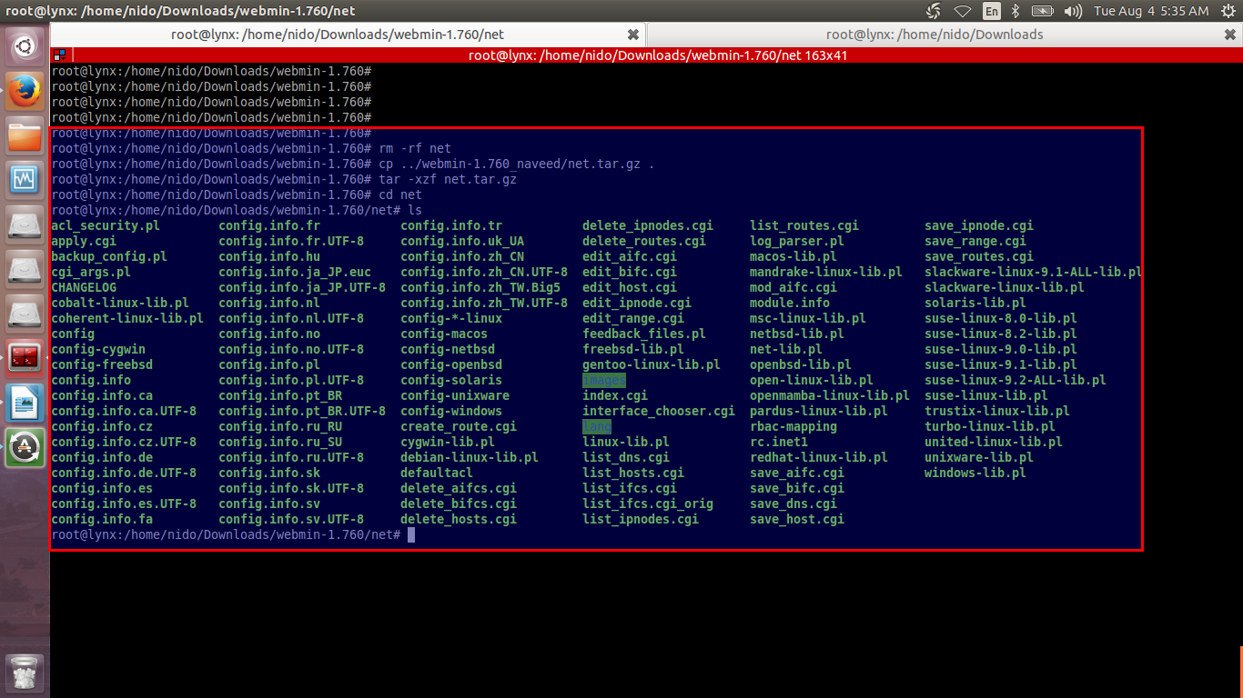

- Submit *only* the files that you modified or created in a tar
archive that we can use to install your changes into our copy of the
baseline code.

I have attached modified module with this document. Please check it.

When we receive your document and new tar archive, we will try again.

Thanks for your detailed email. But I have provided you almost every stuff already and explained every thing in the email. If your team know the webmin then it is an issue to test and evalute it .

I have an option for you. I can you every thing on my Laptop via video link. As you know you were satisifed with my work and I did my best effort to work on your project. It is done my side. However I am here to fix the issue .

I hope this time I will get early update from your side.

